**Gaussian/ Normal distribution Log normal distribution**

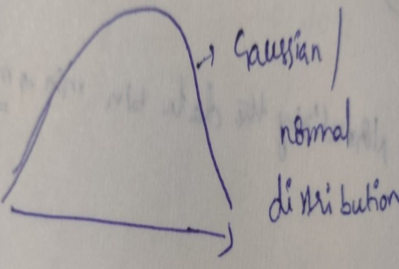 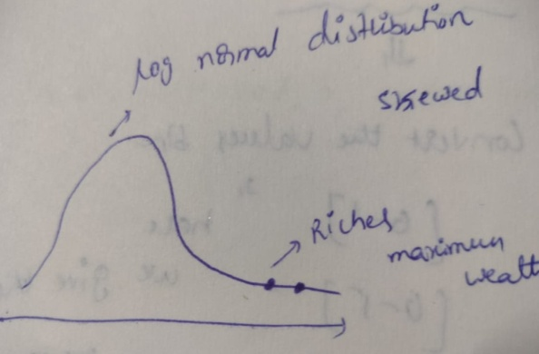

If we apply **log** for Gaussian distribution it will become, **Log normal distribution**. The shape is as follows.

We can say that its right skewed curve.

 

**Log**

If we apply **natural log (Log e)** for **log normal distribution** it will become **Guassian / Normal distribution.**

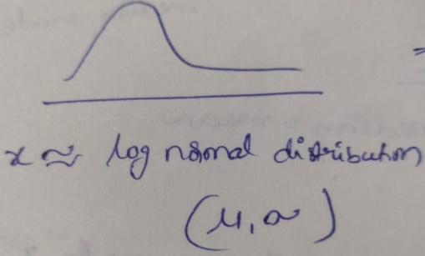 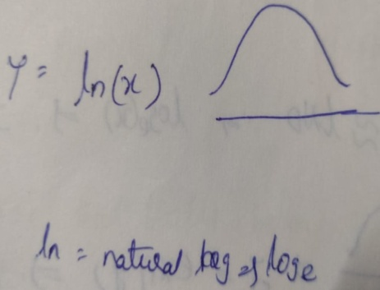

**Natural log / Log (e)**

If we apply **exponential or antilog** to normal distribution, it will become **log normal distribution** as follows.

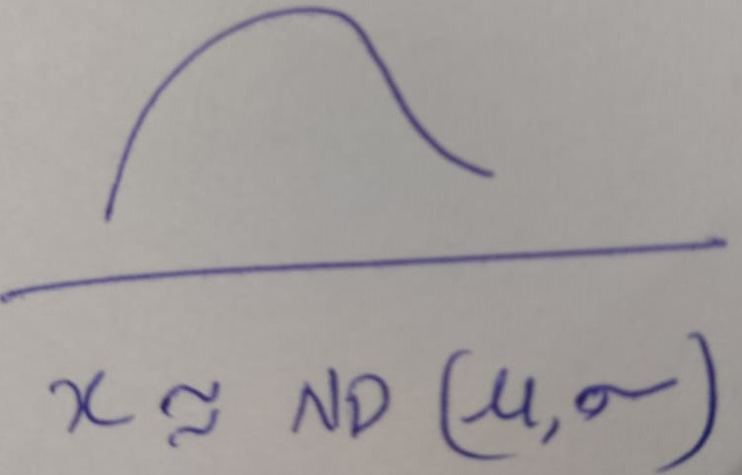 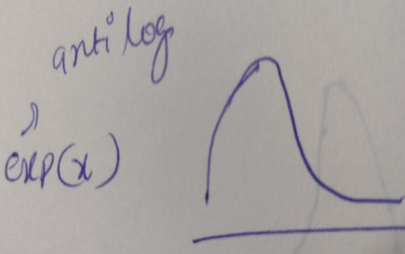

**Exponential or antilog**